1. Open ArcCatalog and go to Customize Mode…

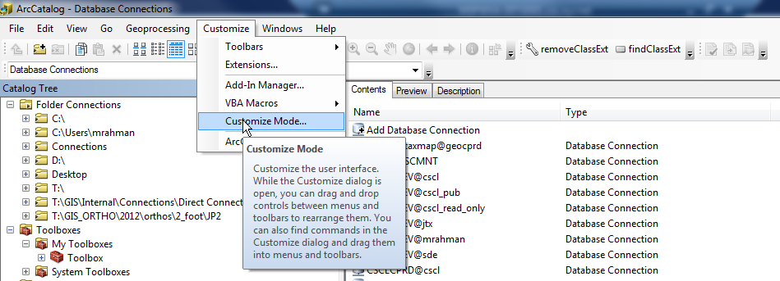

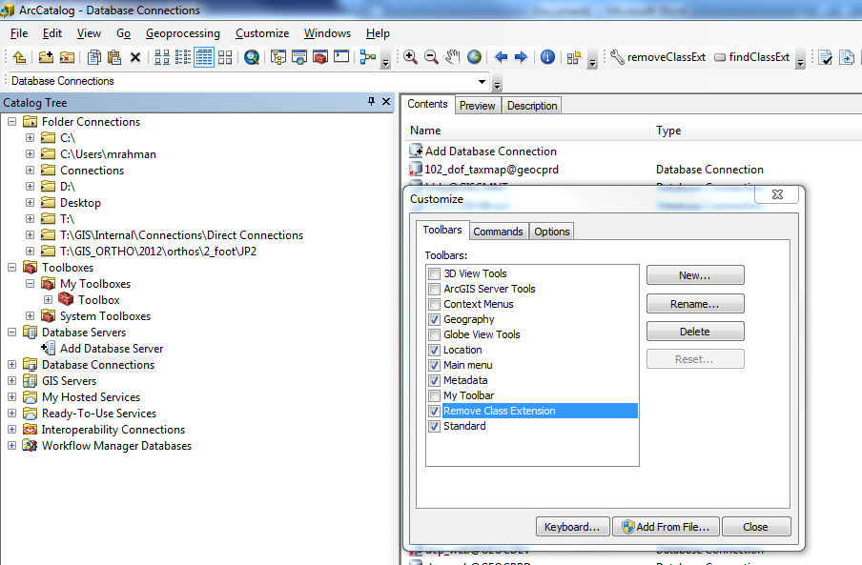

1. Create a new toolbar in ToolBars tab. You can name it “Remove Class Extension”. Enable the toolbar by clicking the checkbox.
2. Now go to the Commands tab and scroll down to [UI Control] Category in the list. Now Click on “New UIControl...” button. A new UIControl window will pop-up.

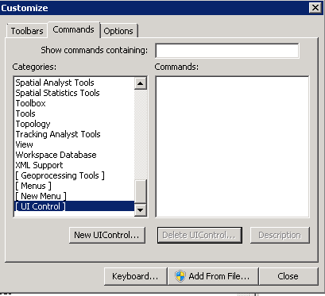 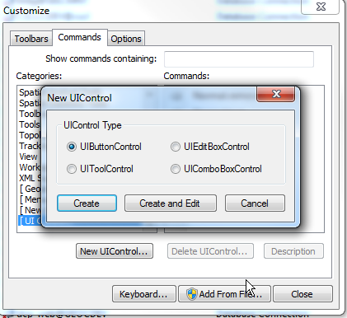

1. Create two UIButtonControls and they should be listed ion Commands: section of the windows. 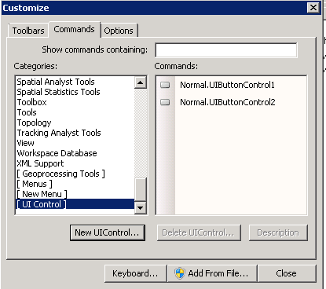
2. You can rename the buttons by double clicking on them. For example, rename to “removeClassExt” and “checkCLassExt”.

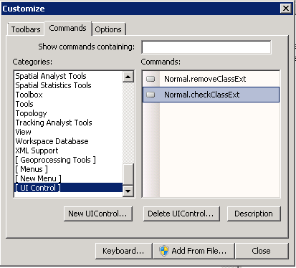

1. Now Click and Drag both buttons to newly created Toolbar in Step 2.

 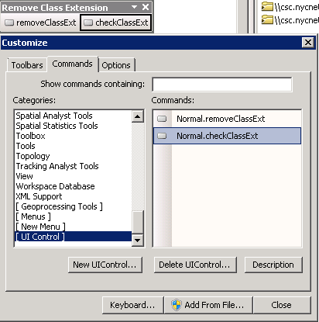

1. In customize mode, right click on 1st Button and go to View Source. It will open VBA editor window and create a VBA Sub Procedures. Do the same for second button. Add “Option Explicit” at the beginning of the VBA editor window.

Your VBA editor screen should look like this: 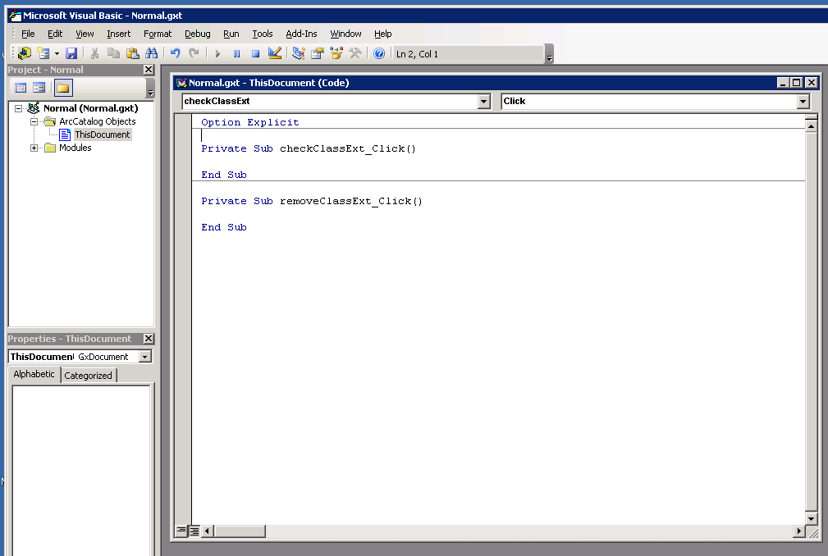

1. Now copy everything from **code.vb** file and paste at the end of code in the VBA editor window.

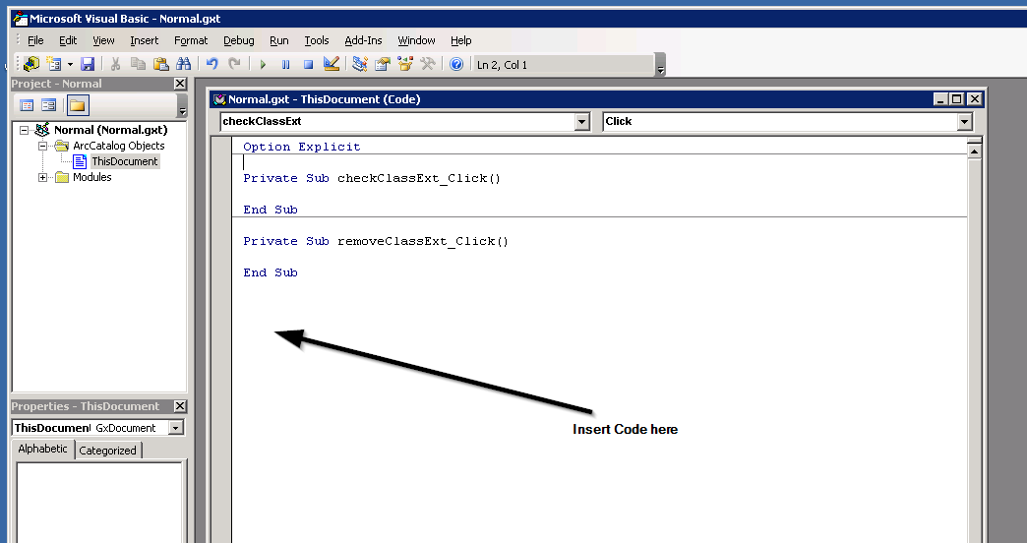

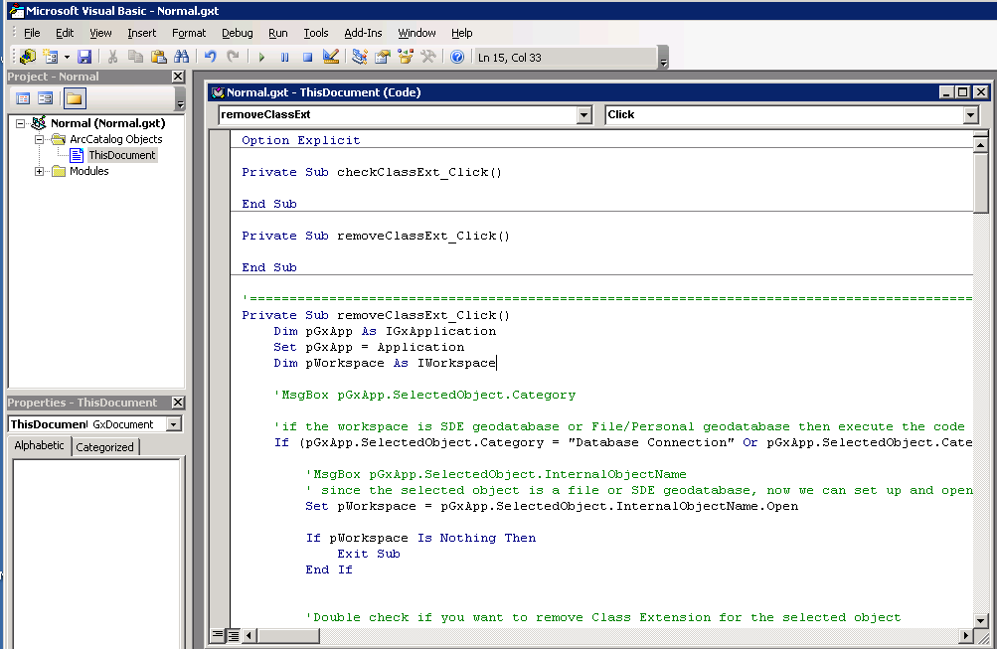

1. Now add the function “removeAllClassExt” inside the sub Procedures of removeClassExt_Click and “checkCL” inside the checkClassExt_Click. Your first few lines of code should look like this:

*Private Sub checkClassExt_Click()*

*'Call the function to check Class Ext in a feature class/ table*

*checkCL*

*End Sub*

*Private Sub removeClassExt_Click()*

*'Call the function to remove Class Ext from the Database*

*removeAllClassExt*

*End Sub*

1. Save the code in in the VBA editor and close & return to ArcCatalog. You should have a toolbar with 2 tools: 